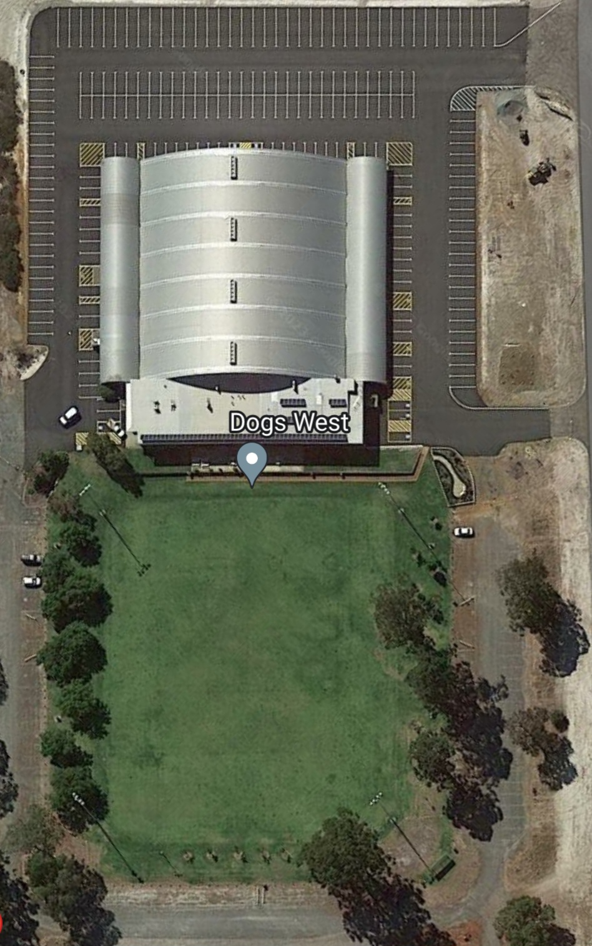
Office | Canteen
Group 6 | Group 1
Group 5 | Group 2
Group 3 | Group 4
gate | Group 7

