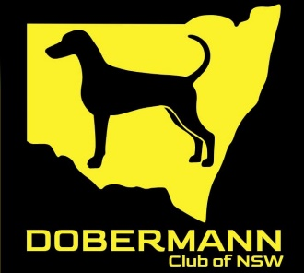
THE DOBERMANN CLUB OF NSW INC SCENT WORK TRIAL
FRIDAY 08 August 2025
OPEN TO ALL BREEDS
THE BILL SPILSTEAD COMPLEX FOR CANINE AFFAIRS
44 LUDDENHAM ROAD ORCHARD HILLS NSW

JUDGES

Masters Interiors – Amenities Building – Penny Mead (NSW)
Masters Exteriors – Courtyard - Donna Puttock (NSW)
Excellent Containers – GSD Building - Sharon Wee (NSW)
Excellent Exteriors – Outside of GSD building - Sharon Wee (NSW)

ENTRIES and CATALOGUE: showmanager.com.au
CHECK IN: self check in from 5.30 PM
JUDGING COMMENCES at: 6 PM all classes after briefing and demo dogs
ENTRY FEES: Members $10.00, Non Members $15.00
ODOURS USED: Excellent - Clove, Birch & Cypress
Masters - all

ENTRIES CLOSE: 04 August 2025 7pm
or when maximum number of entries received

Any changes to entries are to be done online prior to closing date.
There will be no waiting list.
Electronic qualifying certificates will be available on showmanager.

DOGS NSW REPRESENTATIVE: Ms Sandy O’Neill
EXTREME WEATHER: 0414747645

No Bitches in Oestrus permitted on the Grounds
No formal vetting but the club reserves the right to vet any dog on the grounds
No odour to be brought to the grounds
All dogs must be on lead unless an off-leash search is offered
General enquiries – dobeclubnsw@gmail.com
Search area precinct is considered from the last waiting point before search

PRIZES: First, Second & Third each Class - Prize and Sash
QUALIFIERS & TITLE: Ribbon

This trial is conducted according to the ANKC rules for conduct of Scent Work trials

