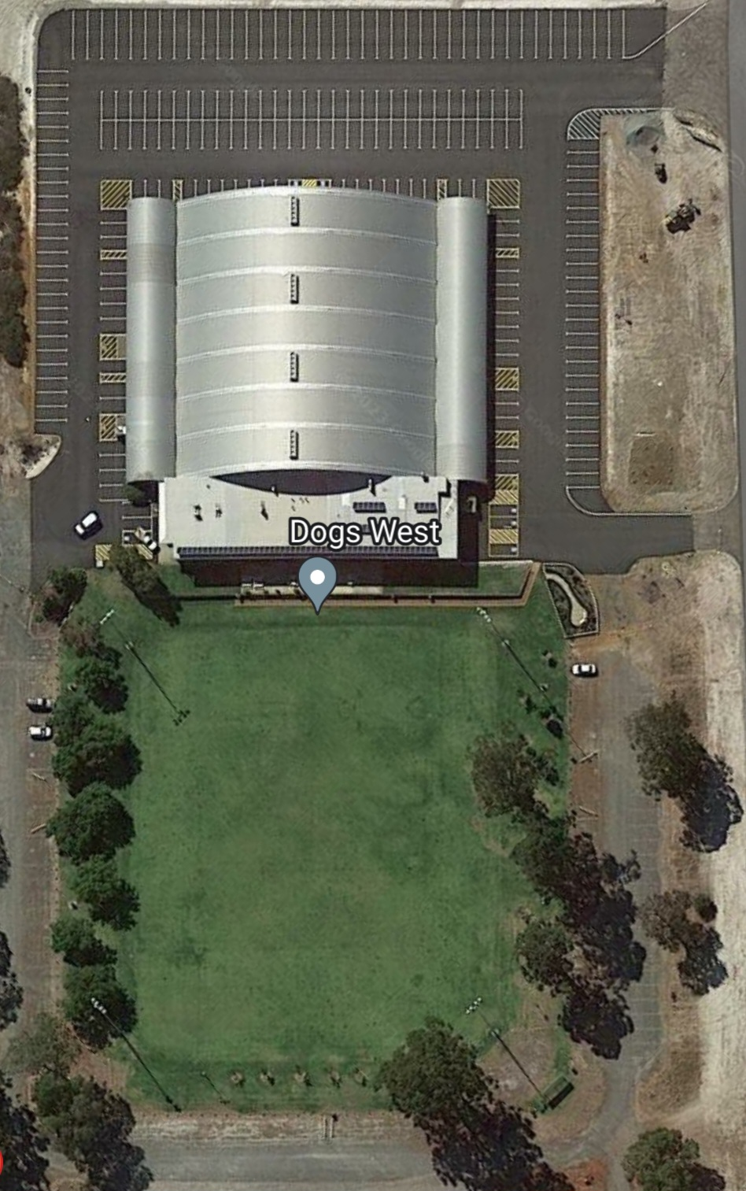

|  |  |
| --- | --- |
| Group 2 | gate |
| Group 4 | Group 7 |
| Group 5 | Group 1 |
| Group 3 | Group 6 |
| Office | Canteen |