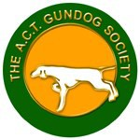
ACT GUNDOG SOCIETY INC
(Affiliated with Dogs ACT (DOGSACT) Inc)

CHAMPIONSHIP SHOW
National Exhibition Centre, Federal Highway, Canberra

Saturday, 22 April 2023
Classes to be judged: 1,2,3,4,5,10, 11, 14 and 18(dogs and bitches)

Mrs Libby Martin (SA)
All Classes & BIS

Order of Judging: Z-A

Judging Commences: Not before 12pm

Entry Fees: $18.00 per entry

Catalogues: Catalogues will be posted online the day before the show

Entries: via Show Manager:
Show Secretary
ACT Gundog Society
Ph: 0410 554 731 (between 7.00pm and 9.00pm)

Entries Close: Online entries close 20 April 2023 (12pm)

Prizes: Trophy and Sash for BIS, RUBIS and all Classes in Show
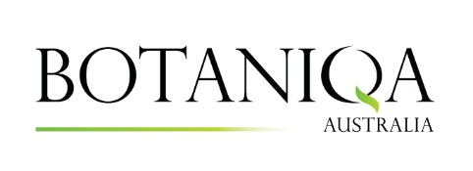
Sponsor

Camping facilities are available, must be booked and prepaid
Contact Dogs ACT office for bookings: admin@dogsact.org.au or (02) 6241 4404

Please note entry to the ACTCA grounds is via Wells Station Road

The ACT Gundog Society Inc reserves the right to change judging arrangements as necessary

