GIPPSLAND OBEDIENCE DOG CLUB INC
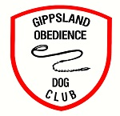
WELCOMES YOU TO OUR
DOUBLE OPEN OBEDIENCE & RALLY TRIALS
MONDAY 12TH JUNE 2023
Toners Lane, Morwell
Wishing all our competitors the very best of luck
Thank you for your entries
Affiliated with the Victorian Canine Association Reg No A00159085
All Rings are on our club grounds – please DO NOT exercise or toilet your dogs on the Baseball Grounds. Please be respectful of this request.

Morning Trial - Check in: 8:00am – 8:45am
Judging commences 9am
Afternoon Trial –Judging commences after the lunch break.
Check in will be available from: 10:30am
The walking of the Rally Courses will be 15 minutes before start time.
Judges may compete in Obedience or Rally at this trial, and as a result judging will start earlier to accommodate these entrants.

Thank you *****VCA REP: LINDY GUMPOLD*****

A Special thank you to our wonderful judges, we hope they enjoy their day.
Morning Trial Afternoon Trail
CCD/NOVICE Mr Gordon Parsons Mr Ray Ashman
OPEN Mr Ray Ashman Mrs Kim Houlden
UD/UDX Mrs Kim Houlden Mr Gordon Parsons
RALLY NOVICE Mrs Gaye Todd Mr Ross Carlson
RALLY ADVANCED Mrs Gaye Todd Mr Ross Carlson
RALLY EXCELLEANT Mr Ross Carlson Mrs Gaye Todd
RALLY MASTERS Mr Ross Carlson Mrs Gaye Todd
** Please note: We have received multiple entries in different classes, and we have tried to avoid clashes, however this can be difficult. Please try your best to be ready when your number is called. Would you kindly inform your judge of your ring/s that you may clash if you have more than 1 dog competing so the judge can move onto another competitor until you are available, whilst not holding up the rings.
**Spelling Omissions: Please if you note a spelling mistake in the catalogue, please notify secretary (Jamie) well before presentation so this can be corrected
GIPPSLAND OBEDIENCE DOG CLUB COMMITTE
President – Eddie Smith
Vice President – Lesley Meikle
Secretary – Roz Buckley
Treasurer – Julie Smith
Trial Secretary Obedience & Rally – Jamie Pendle
First Aid Officer – Eddie Smith

~ A trained dog is a Happy Dog~

TONERS LANE No Through Road
NO PARKING ON GRASSED AREAS NO PARKING ON GRASSED AREAS

COMPETITORS CAR PARKING AREA

DRIVEWAY ENTRY
COMPETIORS CAR PARKING AREA
CAR PARKING CAR PARKING
CAR PARKING CAR PARKING
CAR PARKING CAR PARKING

CAR CCLUB CAGCAD

D
OBEDIENCE
& RALLY RINGS
CHECK IN
CCHECK IN K IN
I
R
C
L
U
B
R
O
OM S

T

R
O
A
D

OUR ALL IMPORTANT SPONSORS - A MASSIVE thank you
Please show your support to them

54 Centre Road Morwell, Vic 3840
Ph: 0455 054 695. Email: sales-vic@gvf.net.au

Contact Talia: 0438 825 423
info@discovercanine.com.au

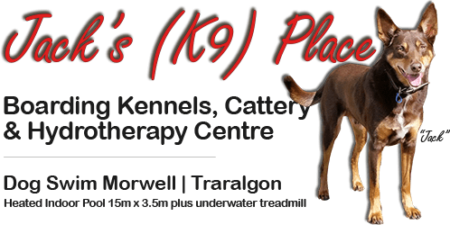
5201 Princes Hwy
Morwell VIC 3840
Phone (answered 8am-5pm) : 0487 261 600

