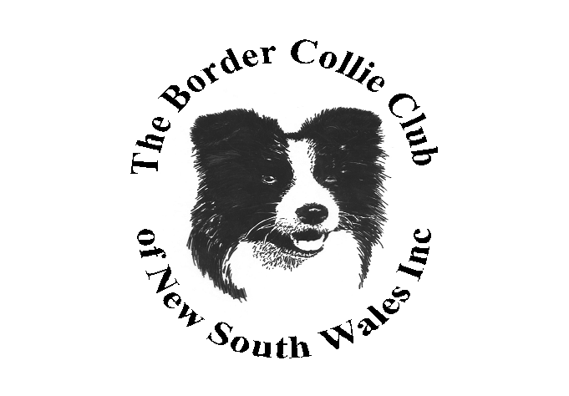

The Border Collie Club of NSW Inc

Championship Show

The Bill Spilsted Complex for Canine Affairs

44 Luddenham Rd, Orchard Hills – Ring 14, Main Grounds

***To be held in conjunction with County of Cumberland All Breeds Kennel Club***

**Sunday 13 November 2022**

**(Entries close on Thursday 10 November at 9.30am)**



Classes to be judged – 1,2,3,4,5,10,11 and 18 – Dogs and Bitches



**Entries:** Online with Show Manager

**Postal**: Show/Trial Secretary, 110 Georges River Road, Jannali NSW 2226

**Ph & Extreme Weather**: 0416 382 138

**Cheques made payable to**: Border Collie Club of NSW Inc

**Judging commences:** With Property Classes – **Start time to be confirmed**

Conformation to follow Property – **Time to be confirmed**

**Judges:**

**Ms Berlinda Shepherdson (SA)**: All Breed Classes and General Specials **(To be confirmed)**

**Ms Tracy Hofman(NSW)**: Property & Special Classes: Sire and Offspring, Dam and Progeny, Gaited, Coated, Headed, Footed **(To be confirmed)**

**Entry Fees:** Breed Classes: Members $12 Non - members $14.

Baby puppies: $5

Property Classes: $5

**Catalogues:** Available to download from 6pm on Saturday 12 November 2022. Will be listed on the “Catalogues – Australian Dog Shows” FB page and the BCCNSWInc FB page.

Pre-Ordered $5.00 on Show Manager.

**Dogs NSW Representative**: Ms Lynda Brandt

**Camping:** Please contact Dogs NSW

**Refreshments:** Available on grounds

**Prizes:** Property: Prize and Sash for 1st, 2nd and 3rd in each Class

Breed: Prize Sash for BISS and RUBISS. Other Classes – Prize and Sash