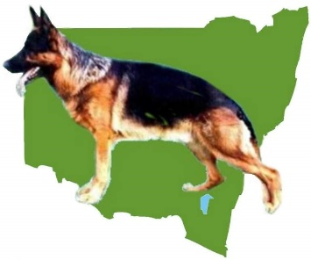
GERMAN SHEPHERD DOG LEAGUE INC

DECEMBER CHAMPIONSHIP SHOW

The Bill Spilstead Complex for Canine Affairs
44 Luddenham Rd, Orchard Hills (GSD Grounds)

SATURDAY 11TH & SUNDAY 12TH DECEMBER, 2021

Classes to be judged: 1,2,3,4, 5, & 11 (Dogs & bitches)

ENTRIES CLOSE – 2ND DECEMBER, 2021

PH & Extreme Weather : 0417414285
Cheques Payable to: German Shepherd Dog League Inc

JUDGE: Mr Glen Gregory (NSW)

Order of Judging: SATURDAY 11/12/21 ALL STOCK COAT BITCHES FOLLOWED BY ALL LONG
STOCK COAT BITCHES
SUNDAY 12/12/21 ALL STOCK COAT DOGS FOLLOWED BY ALL LONG
STOCK DOGS
Judging commences at 9.00 am both days

Initial Entry , $25.00 (includes Catalogue) $22 subsequent entries
Point Score: GSDL Catalogues #3.00

Conformation: Excellent Medallions may be awarded to animals 2 years and over, entered in the Open Class and having been successfully breed surveyed – Animals in Open Class may be gun tested at judge’s discretion,
Prizes
Trophy & Sash to Challenge Dog & Bitch, Reserve Ch. Dog & Bitch and
all class winners.
There will be no intersex judging

ON LINE ENTRIES TO

Paper entries to SHOW MANAGER, P.O. Box 78 Waterview West,Qld 4133

SHOW WILL BE CONDUCTED IN STRICT ACCORDANCE TO COVID-19 RULES

