THE CANBERRA TOY DOG CLUB
&
THE CAVALIER KING CHARLES SPANIEL CLUB OF CANBERRA

GOLDEN GAZEBO HIRE RAFFLE
TWO DAY HIRE

$5.00 PER TICKET
$10.00 FOR THREE

DRAWN : Wed, 22ND April, 2026

There are 2 (two) 3 x 3 mtr HIRE gazebos to be raffled for the two days of shows hence both clubs will benefit from the hire of these gazebos.
Please note : Full sides and silver shade sides will not be included. Exhibitors will need to bring their own.

This is a fundraiser for both clubs and proceeds will be split equally.

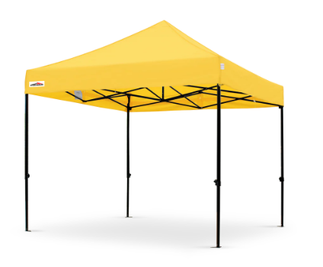

GOOD LUCK EVERYONE

Club Activity can be found on Show Manager

The Canberra Toy Dog Club

