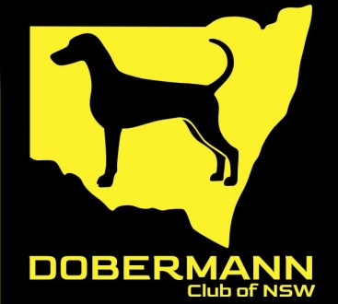

THE DOBERMANN CLUB OF NSW INC SCENT WORK WORKSHOPS -Orchard Hills

Saturday 05.09.26 and Sunday 06.09.26
Trainer/Presenter – Peter Betchley (USA)
The Dobermann Club of NSW is honoured and proud to be the first club to appoint an international judge for one of our trials, and excited to offer learning experience at one of the workshops.

Peters Betchley (USA) Bio:

Peter has had a history with Dobermanns in England where he showed, trained and judged dobermanns in the 1970’s. He then moved to the US where he trained Dobermanns and GSDs in Schutzhund and IPO. He has achieved Sch3, IPO3 and FH tracking titles with his dogs.

Peter has been Police K9 handler for over 10 years tracking narcotics.

Peter currently teaches obedience and Good Canine Citizen classes, does temperament testing and shows English Springer Spaniels.

He is licensed to judge all levels of scent work in US and has judged many trials at National Breed levels including Dobermann Pinscher Club of America Nationals 2025.

Limited Working spots and unlimited Spectating spots:
Times on a particular day will be allocated at a later date.

AM Saturday 05.09.26 8am-12noon
PM Saturday 05.09.26 1pm -5pm
AM Sunday 06.09.26 8am-12noon
PM Sunday 06.09.26 1pm -5pm

Working spots (with a dog) $150
$75 non refundable deposit required to be paid at the time of booking and before 01.06.26

Spectating spots (without a dog) $ 75
$40 non refundable deposit required to be paid at the time of booking and before 01.06.26

Payment is to be made by Direct Deposit to - Account Name The Dobermann Club of NSW
BSB 062 000
Account 009 219 84
Commonwealth Bank - Reference Please include your full name.

