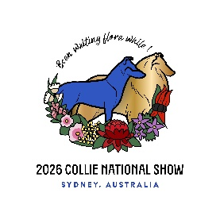
Collie National 2026
Merchandise Information.
ALL Merchandise is pre -order via Show Manager only for collection from July 24, 2026
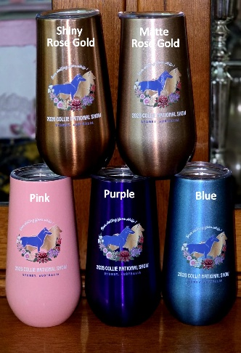
Stemless 6 Oz Champagne flutes with lids 12.5 cm’s in height, double walled food grade stainless steel, individually boxed
5 colours; only 10 of each colour. shiny rose gold, matte rose gold, pink, purple & blue. Each looks GREAT with logo.

Per glass$10
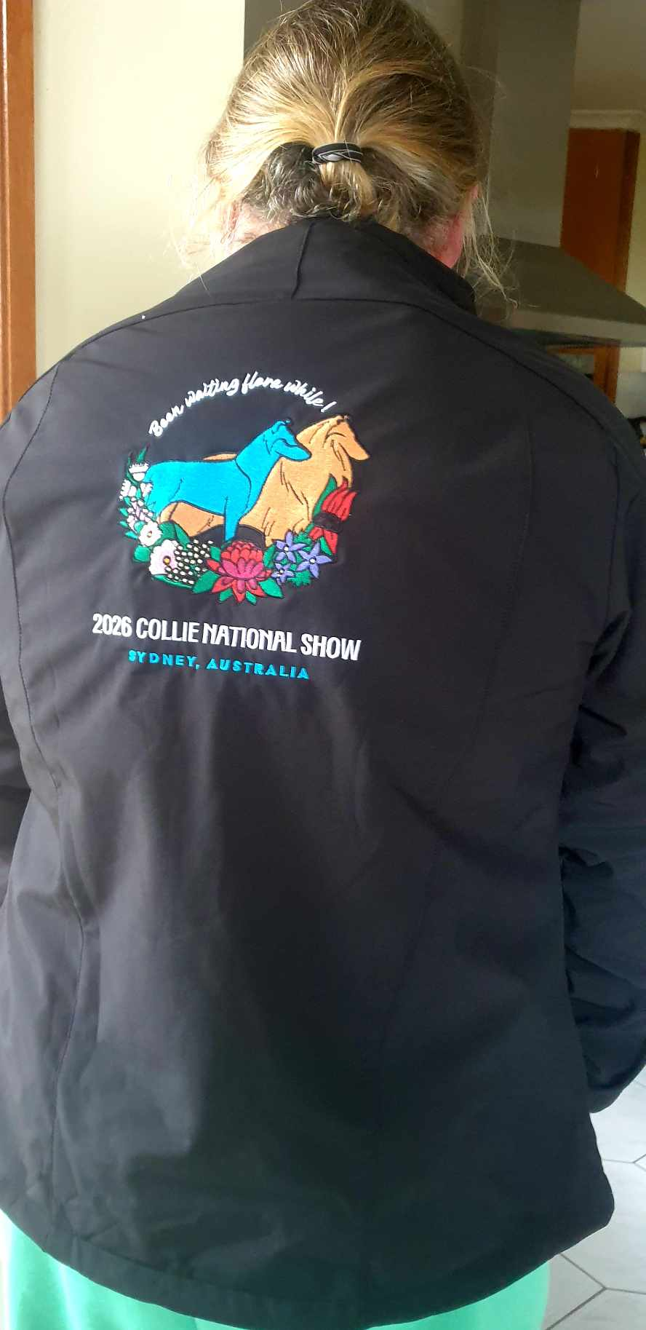
Soft shell jackets
Winning spirit JK15 Rosewall Soft Shell Mens:- https://www.winningspirit.com.au/jk15-rosewall-soft-shell-mens-jacket
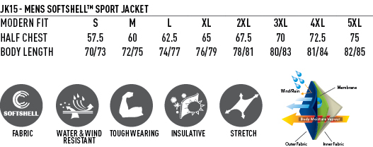
Winning spirit JK16 Rosewall Soft Shell Ladies:- https://www.winningspirit.com.au/jk16-rosewall-soft-shell-ladies-jacket
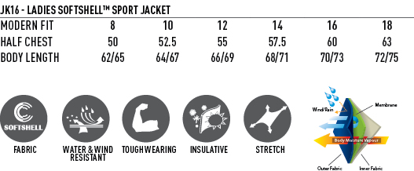
Colours:- Black/Black, Black/Cyan, Black/Orange, Black/Red, Navy/Navy
Embroidered National logo on back only - $100
Back logo and prefix/name front lapel $110
Polo shirts
Winning spirit P561 Alliance polo Mens https://www.winningspirit.com.au/ps61-alliance-mens-polo
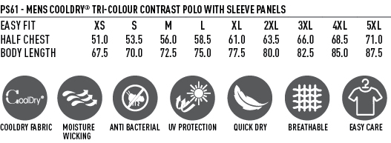
Winning spirit P562 Alliance polo Ladies https://www.winningspirit.com.au/ps62-alliance-lady-polo
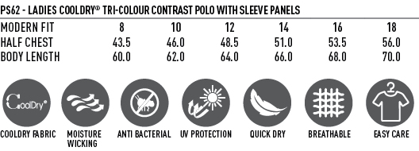
Winning spirit P561k Alliance polo kids https://www.winningspirit.com.au/ps61k-alliance-kids-polo
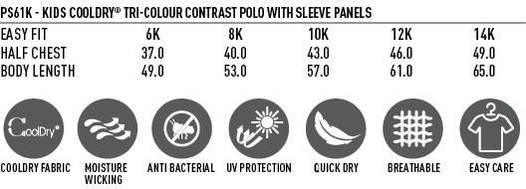
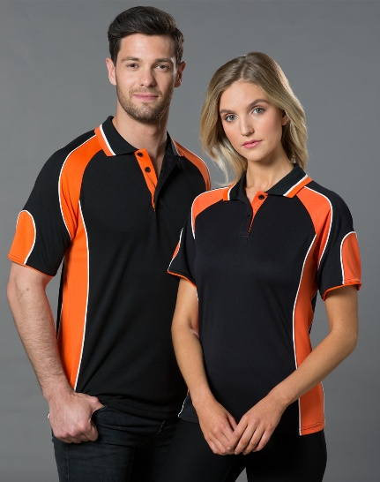

Colours:- Black/Aqua blue, Black/Orange, Maroon/White, Navy/Red & Navy/White – These are the colours the design will work best on.
Embroidered National logo on back only - $65

Hoodies
Colour:- Charcoal only
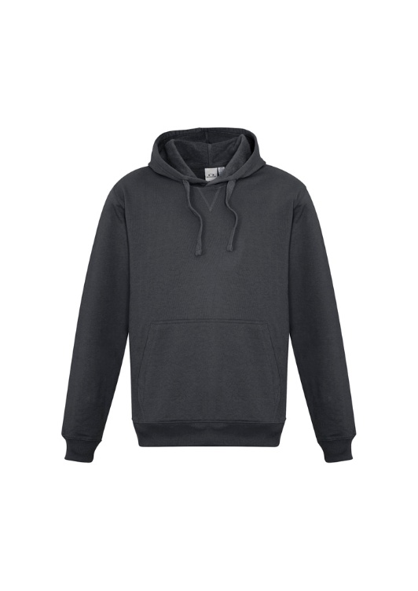
Mens :-https://www.bizcollection.com.au/product/sw760m

Ladies:-
https://www.bizcollection.com.au/product/sw760l

Children:-
https://www.bizcollection.com.au/product/sw760k
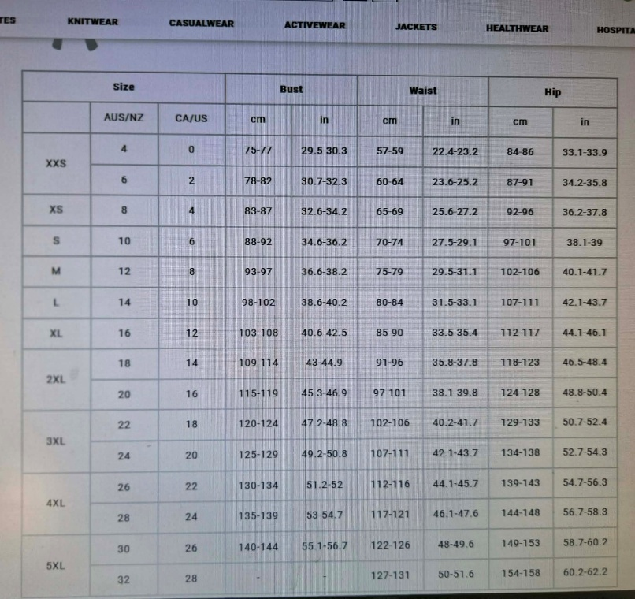
DTF transfer printed (logo on back) $85
Personalised with prefix/name $95
____________________________________________________
Embroidered items are from AK Embroidery art https://www.facebook.com/akembroideryart
Transfer printed clothing from Brisbane screen printing https://www.facebook.com/profile.php?id=100009117081412
______________________________________________________________
Orders will close June 1st 2026
T-Shirt
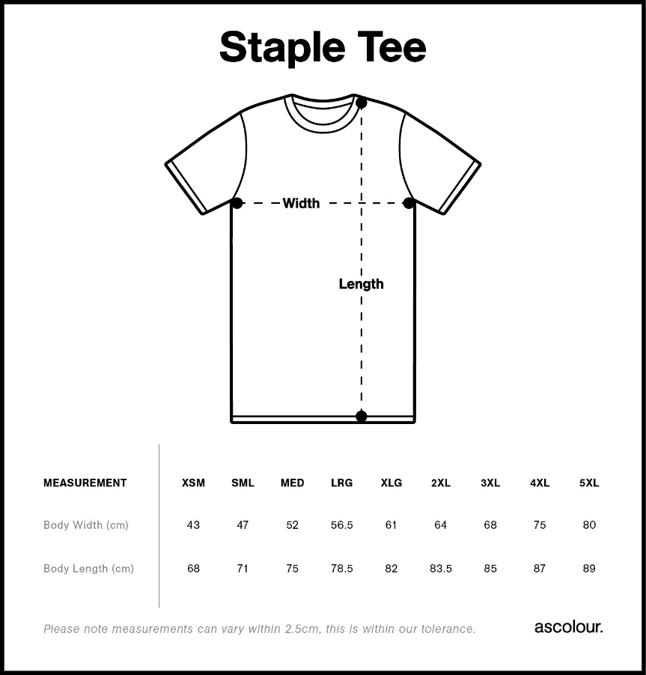
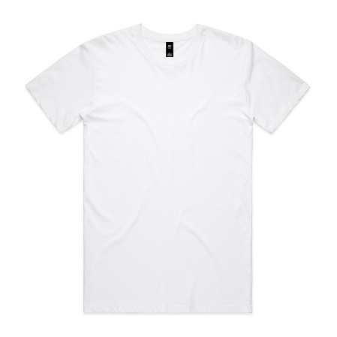
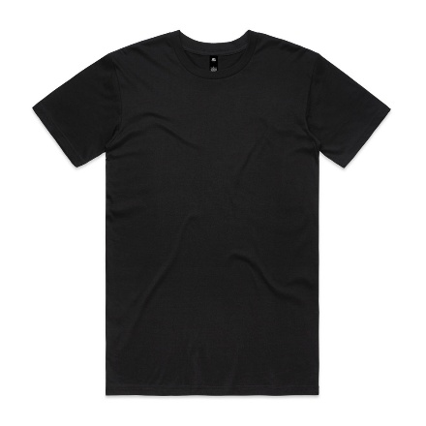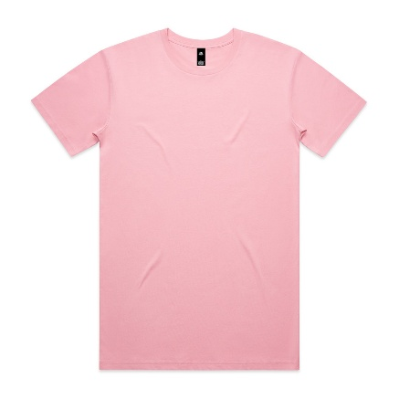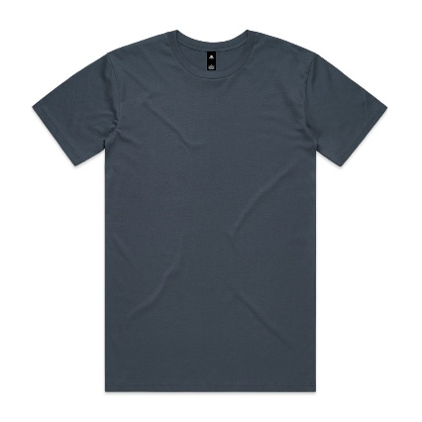
Colours:- White, Black, Bubblegum & Petrol Blue
DTF transfer printed (logo on back) $50
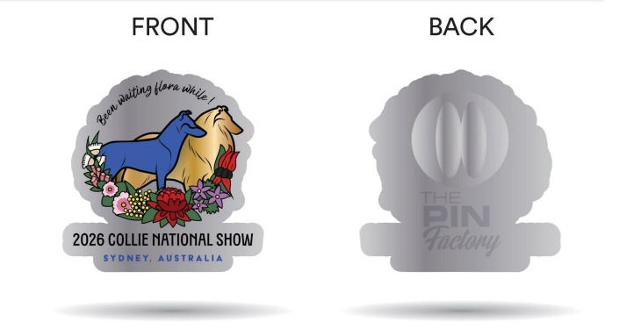
$10 collect at National
+ postage if wanted before hand – please enquire jed_2807@yahoo.com

