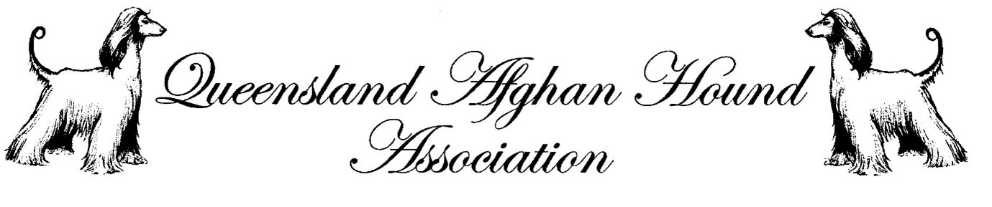RAFFLE
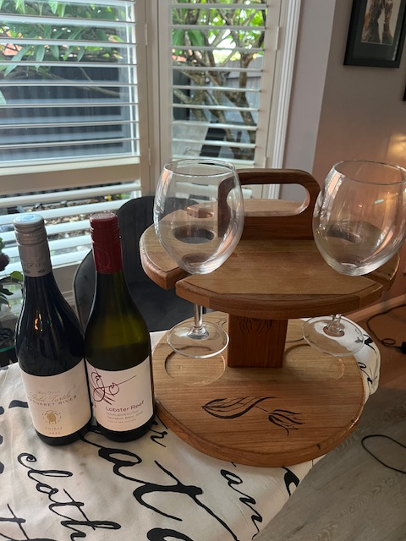
1st Prize: Wine picnic table, wine (Red and White), and wine glasses
OR
$150 Laserlites Coat Care Voucher

2nd Prize alternate 1st prize

3rd prize 2 bottles of wine 1 red, 1 white

4th prize $50 Bunnings Voucher

