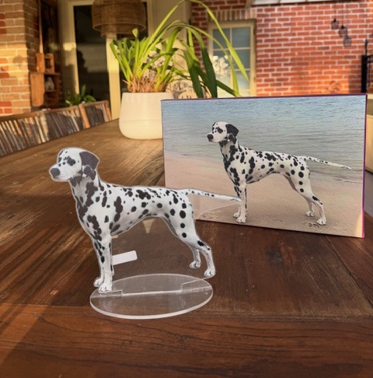
DALLIES PAST AND PRESENT FUNDRAISER.

Calling pics of dallies past and present, to stand guard at the 19th National Dinner.

For just $15, you can submit your photo to be made into a 2D flat Acrylic statue.

These will be on the tables as decorations at the dinner to spark conversation. You can then take home your picture at the end.
Picture of photo and the made acrylic. These are flat 2d.
Please order and pay through Show Manager then email your picture and your SM Receipt to daqsec@outlook.com. NOTE- it will be up to you to send a quality pic as all pics sent will be submitted to manufacturer while due care taken, we will not be responsible for returned image quality. Pictures must be received by 5pm 1 June 2026.
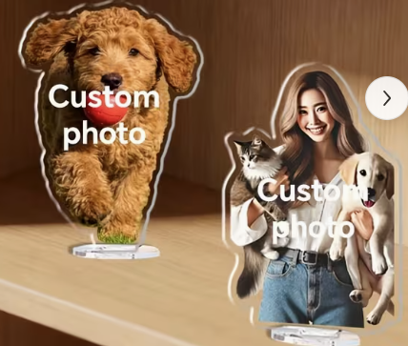
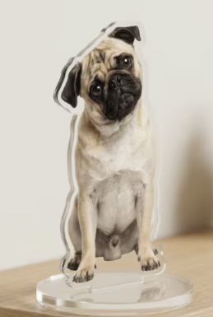
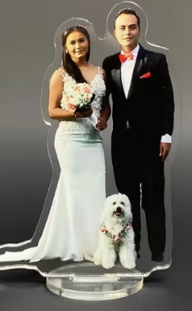
It can be lots of poses eg -, stack, sit, agility jump, with you, playing with friends. They will either have an acrylic base or a wooden base depending on what is available at the time when we put in the bulk order.

