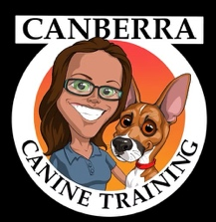
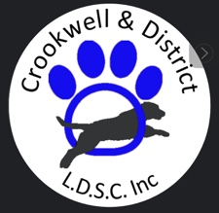 Scent Work Workshop with Amy Smith from

Canberra Canine Training

- Date: 19/07/2026
- Time: 9:00 AM – 5:00 PM
- Location: CWA Hall Spring and Robertson St Crookwell
- Cost: $70 per dog-handler team for a working Spot
- Cost: $30 Auditing Spots

Whether you’re brand new to Scent Work or already trialling, this workshop will take a practical look at the foundation skills that support successful searching. Throughout the day, we’ll work through a variety of exercises designed to help identify where gaps in training, handling, clarity, or understanding may be limiting progress.
We’ll look at things like search commitment, independence, clarity, handler influence, motivation, and problem-solving skills, with exercises adapted to suit individual teams and experience levels.
The goal of the day is to better understand what your dog is telling you, identify where training may need strengthening, and leave with clearer direction for future training.
Amy has been working professionally as a dog trainer for over ten years, with a background in horses spanning the decade prior. She is deeply passionate about ensuring our dogs have the clarity and consistency they need from us to successfully navigate the human world.
In addition to her scent work instructor accreditation through the National Association of Canine Scent Work (International), Amy holds qualifications in applied behaviour and ethology. This behavioural lens allows her to bring a unique perspective to her scent work training.
As an active scent work competitor herself, she also understands the importance of training in ways that translate clearly and efficiently into the competition environment.
Spaces are limited, so book now to secure your spot. https://showmanager.com.au/activity/4649

For enquiries contact us at crookwelldogsports@gmail.com or ring Sue on 0418 655519

