

Australian National Kennel Council Ltd ABN 77 151 544 679 trading as Dogs Australia

Rules for the Conduct of Canine Grooming Championship Competitions

(Effective from 1 January 2025)

Adopted by the Member Bodies of the Australian National Kennel Council Limited June 2024

TABLE OF CONTENTS

Page No.
SECTION 1 – GENERAL RULES

  - The Show Ring 1
    - Allocated Spot 1
  - Additional Requirements 1
  - Refunds and Changes 1
  - Check in Procedures 2
  - Pre-judging and Entry Confirmation 2
  - Judges will undertake the following during pre-judging 2
  - Product Application 2
  - Assistance during the show 2
  - Break 2
  - Judging 3
  - Competition End 3
  - Show Manager 3
  - Codes of Conduct and Ethics 4
  - Code of Practice (Judges and Competitors) 4
  - Promotion Activity 6
  - General Information 6
  - Miscellaneous 7
SECTION 3 - CHAMPIONSHIP SHOW COMPETITIONS
  - Preface 13
  - Objectives of Canine Grooming 13
  - Canine Grooming General Rules 13
Dogs Australia Recognised Breeds admitted to compete at
Championship Show 14
  - Group 1 - Hand stripping 15
  - Group 2 - Spaniel/Setter 15
  - Group 3 – Poodle 16
  - Group 4 – Scissoring 16
  - Group 5 – Salon Freestyle 17
  - Special Classes 17
  - Classification of Levels 17
  - Awards and Prizes 19
  - Group Placements 19
  - Best in Show Placements 19
  - Best in Show for Level B 19
  - Best in Show for Level C 19
  - Best Freestyle in Show 19
  - Best Asian Fusion in Show 19
  - Awards and Prizes 19
  - Group Placements 20
Time Allocation – Championship Show 21
  - Entering 22

SECTION 1 – GENERAL

The Show Ring
    - The following is strictly prohibited:
- Use of phones, radios and headsets
- Standing on tables or chairs
- Beverages NOT in spill proof containers
- Coaching by anyone, at any time during the competition
- Visual or written instructions

Allocated Spot
      - The allocated site for exhibitors to groom should be proportionate to the size of the dogs but must be a minimum of 170 cm (length) x 150 cm (width) in area and must have a 50 cm walkway.
      - Any equipment used in the formation of a grooming ring must meet minimum safety standards to prevent injury to officials, judges, or animals (e.g., electrical connections are prohibited).

Additional Requirements
- Only cordless clippers and equipment permitted. No power is provided.
- Professional Conduct by Competitors
- Appropriate grooming attire and shoes must be worn at all times.
- Inappropriate attire would be considered as very short skirts, tight shorts, and low-cut blouses.
- Open toe shoes are not permitted.
- A professional manner and attitude must be maintained at all times
- Competitors must maintain a safe styling counter at all times (as an example: Open scissors left on the table for the dog to step on would be considered unsafe styling counter).
- Competitors must practice kind and safe handling techniques at all times.
- Dogs must not be left unattended at any time.
- Competitors must apply technical skills with safety. Nicks, cuts and clipper burns are considered unsafe technical skill application.
- Good sportsmanship must be displayed at all times.
- It is the responsibility of each contestant to clean up after their dog both inside and outside the venue, including all clipped hair.

Refunds and Changes
    - Cancellation of entry may incur a 5% Administrative and Processing fee and will be deducted from the refund.
    - No refund of entry fees will be made after the closing date of entries.
    - Entry fees are also not refundable in the event of the Competitors being withdrawn, disqualified, or the show cancelled unless otherwise specified by the Show Organizers.
    - No changes will be made after the closing date of entries.
    - Any class change may be permitted after the closing date with the approval of the member body and only in exceptional conditions.

Check in Procedures
- The check-in counter will open one (1) hour prior to the contest commencement time.
- Competitors will have the pre-contest photographs taken.
- The check in counter will close 15 minutes prior to the start time
- Competitors will present themselves and their dog at check in counter 45 to 60 minutes prior to commencement time.
- Competitor who has not checked within 15 minutes before the contest commencement time may not be permitted to compete
- Model dogs may be submitted at the check in counter from 7:30am to 10am (Championship Show only)

Pre-judging and Entry Confirmation
- Dogs should be clean, dry, and preferably mats and tangles free.
- Nails should be clipped and/or filed and ears clean.
- Sanitary and pads can be clipped prior to the show.

Judges will undertake the following during pre-judging:
- Confirm that the dog is entered in the correct class;
- Confirm that there is sufficient coat growth and evaluate preparation. (Note - Dog models must not be groomed for 60 days or more prior to the date of the competition except for the flatwork areas of stripping breeds which may be groomed up to 20 days (Championship/Open Show) and 30 Days (FCI Show) prior to the competition.
- Confirm the time frame permitted according to size, breed or technique;
- Confirm that the contestant is entered in the correct division;
- Determine if pattern has been pre-set.
- Document specific information relating to the health and presentation of the dog such as, but not limited to: ear infections, missing coat, moles, scars or healing injuries.

Product Application
- Spray is limited to only “freshening up” once time is called.
- Reshaping such as that done on Kerry Blue jacket, shaping or patting coat into place, utilizing water or product or shaping a show Poodle headpiece may not be done once time is called.
- Chalk, such as terrier chalk may be applied prior to or during the show time frame to aid in hand stripping. It is prohibited to apply chalk after time is called.

Assistance during the show
    - The Competitor should notify the ring steward immediately if he/she needs assistance during the competition.

Break
- (Championship Show) A mandatory break will take place during the show.
- (Open Show) A minimum 10-minute mandatory break will take place during the show at each session.
- All Competitors and dogs must proceed as a group to the designated break area.
- Water will be offered for both Competitors and dogs.
- Toilet/potty break opportunity available for both Competitors and dogs

- Any discussion with regard to dogs or grooming by Competitors or assistants is prohibited and could be construed as coaching which may result in disqualification of offending contestants.
- No grooming or styling of any kind is permitted during the break

Judging
    - In order to determine placement, Judges will evaluate the following:
- The Profile of the dog groomed to.
- The overall uniformity of the trim.
- The overall balance, symmetry and style of the trim.
- For purebred dogs, the adherence to the acceptable breed profile and standard.
- For Freestyle classes, the ability of the groomer to create the best possible profile for the dog chosen according to his/her body type, coat and structure.
- For scissored dogs, the plush overall appearance without scissor marks, utilizing the proper technique.
- For hand striped and carded dogs, the smooth and natural appearance utilizing the proper technique.
- Clipper lines should be clean and free of irritation.
- Edges such as in the cocker foot or poodle foot should show neat and tidy bevels.
- Consideration given to difficulty with regard to the amount of coat removed, whether a pattern is created or followed, difficulty of the coat type, texture, quality and quantity and how the stylist achieves the ultimate trim.

Competition End
- When time is called Competitors will cease grooming and place tools on the table.
- The competitor will remove hair, tools and equipment from grooming table.
- A comb will be placed on the table.
- Competitor may comb their dogs after scissors down, prior to and after judging.
- Competitor may use finishing sprays to freshen up their dogs after scissors down, prior to and after judging, but reshaping or styling with hair spray, products or water is prohibited.
- Competitor will stack and present their dog to the judges.
- Ensure that the dogs have proper grip on the table when being stacked and presented to the judge

Show Manager
    - The Show Manager shall ensure that:
- All Policies, Procedures and Rules are adhered to by Grooming Exhibitors;
- They do not influence or otherwise provide advice to Judges with regard to placements.
- Show organizers reserve the right to reject entry of competitor/s without assigning any reason.
Note: 1.12.1 c) may be subject to member body appellative procedures.

Codes of Conduct and Ethics
    - We are committed to building a safe and inclusive environment where everyone can participate in our competition. This includes fostering respect, fairness, and equality for all participants, regardless of their background, experience level, or identity. We strive to ensure that our events are welcoming and accessible, promoting a culture of inclusivity and mutual respect.

We are Inclusive
We come from diverse backgrounds and share different views. We value and celebrate diversity and we respect the rights and dignity of each other. We are equal and are committed to zero tolerance for discrimination and bullying.

We make Canine welfare and health our priority
We do not engage in, or allow others to engage in, activities that put the welfare and health of our dogs at risk

We strive for safe environment
We do not engage in, or tolerate, threatening, aggressive or violent language and behavior. We do no incite or encourage hatred or violence. We do not intimidate or abuse our judges or stewards

We respect the judge's decision
We acknowledge that the competition judge's decision may not be perfect, but we do not call into questions their integrity, abuse or belittle them. We are grateful for the important and challenging role they play in our competition. We always show respect for the judge and other show officials

We play fairly
We do not cheat. We compete by the rules and the expected standards of fair competition.

We respect public property and spaces
We do not damage property, we follow event rules. We keep our grooming station clean, put our rubbish in the bin. and we pick up after our dog. We represent member of DA Canine Grooming in a positive way.

We are good sports
We respect good play whether from yourself or the competitor. We thank the competitors and officials after the competition and we are gracious – win, lose or draw.

We keep our competition Fair and Honest
We do not engage in dishonest or any corrupt practices. We are here to compete with integrity, respecting their opponents and abiding by the rules, regardless of the outcome and we hold each other to these Standards

Code of Practice (Judges and Competitors)
    - No person shall enter the show if the judge owns the competing dog. If the judge previously owned the dog, the person shall not enter under that judge within twelve (12) months from the date of ownership.

    - A judge who has prepared or privately provided or bred the competing dog to a person in the class that they are judging must not adjudicate.

    - No person shall enter under a judge if the judge has groomed the competing dog within six (6) months prior to the show.

    - No person shall take any grooming products or tools belonging to the judge in the ring at which the judge is officiating.

    - No person of a Judge’s Immediate family or household including a person who resides at the same address or a judge's partner, shall enter the show.

    - No person shall enter under a judge if that person has accommodated that judge or been accommodated by that judge in the period of twelve (12) months prior to the show or intends to accommodate the Judge within 72 hours after the show.

    - No person shall enter under a judge if that person has;

- Instructor-Student Relationship - A person is disqualified from competing under a judge if there has been any form of instructional relationship, including as an instructor, student, or apprentice. This rule encompasses all personal mentoring, coaching, or tutoring activities (as defined below).

- Private Lessons - If a person has received private training or semi- private training at hands-on workshop from the judge, the person shall not compete under that judge within the 12 months, from the date of the competition.

- Exceptions – 1.14.7 a) and b) does not apply to:
  - Seminars
  - Virtual or online subscription training
  - Grooming critiques at competitions or show rings
  - Non-face-to-face tutoring
  - Gaining TAFE work experience

- No person shall enter under a judge if that person has a vested business relationship with the judge including that of consultant, sub-contractor, or leasing within twelve (12) months prior to the show.

- No person shall enter under a judge if that person has the same current Sponsorship or Brand Ambassador as that judge.

- Promotors and Show Managers do not allow their own sponsored groomer to enter.

- A judge must request that the person be withdrawn from competition if the judge has a conflict of interest with the competing dog/the groomer for example employer or employee relationships, financial considerations, separate interest in a Grooming School or Salon, handled or co-owned a dog with the judge. This is not a definitive list of examples.

- A person shall not enter under a judge with whom you travel to shows with. "Travels to shows" would also include those with whom one shares a hotel room or regularly dine/park/set up together at dog or grooming shows.

Promotion Activity
    - A person shall not display inside or in view of the judging ring:

- Wearing badges, clothing, jacket or other garments with visible sponsorship, ambassador or anything which indicates or might indicate they are a member of Groom Team of certain Company, Brand or Country.
- Contestants are not allowed to wear clothes advertising a salon, kennel name or grooming products in the ring.
- Any cards, ribbons, rosettes or trophies except those won at the show.
- Any advertising materials

    - Rule1.15.1 does not apply to:
- General merchandisers where any person would able to purchase from an open market
- After the completion of the General specials.

General Information
    - The use of hairspray is allowed
    - The use of powder/chalk and volumiser is breed-specific and not allowed for just any breed.
    - Breeds that require it are West Highland White Terrier, Fox Terrier (Wire), Welsh Terrier & Schnauzers (all sizes). Use of those items should be done before the start of the competition.
    - Any products that change the colour, nature and texture of the coat will not be allowed.
    - Participants must be older than 18 years old. Those under 18 require parental consent.
    - Model dogs must not be groomed for 60 days or more prior to the date of the competition except for the Rolled Coated Stripping breeds.
    - There will be a compulsory 10-minute break for dogs and/or contestants to rest in the middle of the competition.
    - Model dogs for Poodle Puppy Clip must be under 15 months old.
    - The contestants must provide their own model dogs and their own canine grooming tools and table.
    - The contestants must ensure that their dogs are duly vaccinated and provide proof of vaccination if required by the organizer
    - A grooming arm is allowed. However, the safety and welfare of dogs is of utmost importance. If a dog is found to be short of breath on the table due to the use of a grooming arm, points must be deducted.

    - Points will be deducted if the canine groomer is found to be untidy with his equipment. Contestants need to be in the ring 30 minutes before the start of the competition for prejudging.

Miscellaneous
    - From time to time, some changes to these rules may be necessary. Amendments of these Rules and Regulations can be recommended by the National Canine Grooming Committee (NCGC) for consideration by the Board.

SECTION 3 – CHAMPIONSHIP SHOW COMPETITIONS

Preface
    - The purpose of these rules is to encourage the canine groomers to further develop and extend their skills by participating in canine grooming competitions.

Objectives of Canine Grooming
    - The objectives of canine grooming are:
- Preserving the traditional trims that many young canine groomers have lost in today's canine grooming shows.
- Promoting conformation canine grooming

Canine Grooming General Rules
    - Classification of Categories Five (5) categories are offered in the competition. There are four (4) levels offered within each category

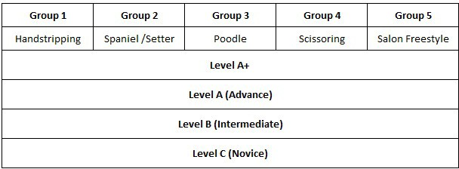

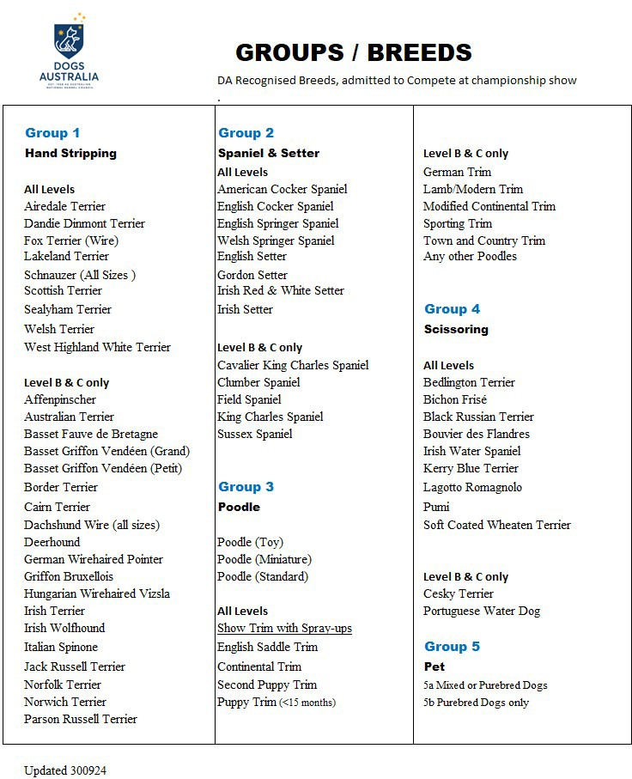

Group 1 - Hand stripping
- Dog models must not be groomed for 30 days or more prior to the date of the competition except for the flatwork areas of stripping breeds which may be groomed up to 20 days prior the competition
- All dogs may have their sanitary and pads shaved prior to the start of class.
- The coat must be carded or hand stripped.
- The coat can be rolled up to 3 weeks before the show.
- There should be no visible pink skin or bald patches after grooming.
d) Chalk, such as terrier chalk, may be applied prior to or during the time frame to aid in hand stripping. Enhance the coat colour; chalk is permitted in Level A only and shall not easily transfer onto judges' hands.

    - Restrictions
- Level A+ & A - Clipping/Scissoring is not permitted (see exemption breeds).
- Level B - Clipping and excessive usage of scissors will be penalized.
- Level C - Clipping and scissors are permitted.
    - Exemption Breeds (Clipper permitted):
- Schnauzer - Ears, Head, Neck, and inside of back legs only.
- Scottish Terrier - Ears, Head, Neck Only.
- West Highland Terrier - Ears and Neck only.
- Sealyham Terrier - Ears, Head, Neck only.

Group 2 - Spaniel / Setter
- All dogs must be groomed according to breed standard and as presented in the conformation show ring
- Dog models must not be groomed for 60 days or more prior to the date of the competition
- Thinning scissors are not permitted to be used on the jacket.
- Thinning scissors can be used for blending ears, head, face, neck, and rear.
- Chalk is allowed.
- Clipping is allowed on the face, neck, chest, and ears.
- All dogs may have their sanitary and pads shaved prior to the start of class.
- Finishing sprays are permissible to tidy up after the time frame ends.
    - Restrictions
- Level A+ & A - Thinning scissors are strictly not permitted to be used on the jacket.
- Level B - Minimal usage of clippers and thinning scissors is permitted on the jacket but not encouraged.
- Level C - Clipping and thinning scissors are permitted on the jacket.

Group 3 - Poodle
- All dogs must be groomed according to breed standard and as presented in the conformation show ring
- Dog models must not be groomed for 60 days or more prior to the date of the competition
- All Poodles can have their sanitary and pads shaved prior to the show.
- All Poodles can have their face, feet, & tail shaved prior to the show.
- Topknot bubble must be done during the show time frame; bandings can be done prior.
- Finishing sprays are permissible to tidy up after the show time frame ends.
- Hairspray may be used at any time throughout the showtime.

    - Restrictions
- Level A+ & A:
  - Clipper guide combs are not permitted.
  - Show trims with spray up only (i.e., English Saddle, Continental, or Scandinavian (Second Puppy).
  - The topknot bubble must be done during the competition time frame.
  - Hair extensions are permitted and shall be of the same coat colour as the dog and can be applied before the competition.
  - An extra 20 minutes will be added for show trims.
  - Hairspray can be used on the topknot at any time throughout the competition time.
  - A thin layer of hairspray can be applied to the topknot before the competition but must be able to be combed through at prejudging.
  - Show collar to be applied before spray up.

- Level B & C:
  - Clipper guide combs are permitted.
  - Trims permitted at your level are German Trim Lamb/Modern Trim Modified Continental, Sporting Trim Town and Country Trims, or Any other Pet trims.

Group 4 - Scissoring
- All dogs must be groomed according to breed standard and as presented in the conformation show ring
- All dogs may have their sanitary and pads shaved prior to the start of class.
- Finishing sprays are permissible to tidy up after the show time frame ends.

    - Restrictions
- Level A+ & A - Clipper guide combs are not permitted.
- Level B - Minimal usage of clipper guide combs is permitted.
- Level C - Usage of clipper guide combs is permitted.

Group 5 (Salon Freestyle)
    - This is an inclusive group for any breeds groomed in the everyday salon style.
    - Any crossbreed in the everyday salon style or groom any purebred in the teddy style. Examples: Poodle in Bedlington trim or Old English Sheepdog in a teddy bear trim.
    - Poodle face and feet may not be shaved.
    - Points are awarded for skills in clipper work, scissor work, balance, symmetry & scissor finish.
    - All dogs may have their sanitary and pads shaved prior to the start of class.
    - Finishing sprays are permissible to tidy up after the time frame ends.
    - These classes are for exhibition only and are not eligible for Best In Show awards.

Special Classes
    - Special classes may be offered at approved championship shows.
    - These classes are for exhibition only and are not eligible for Best In Shows awards.

    - Asian Fusion - Teddy trim with an Asian flair, some colouring, clothes, and accessories are permitted. Coat carving is permitted, for example: spirals, wings, love heart, etc.

    - Model Dogs - Canine Grooming shall be completed at home and brought for judging on the day of the competition.

    - Asian Fusion - dogs may be altered, modified, and minimal colours permitted. Bows, decorations, and accessories permitted

    - Creative - dogs may be altered, modified, and coloured. Bows, decorations, and accessories permitted

    - Pure Breed - dogs may be altered, modified, and coloured to achieve any recognized ANKC recognized breed.

Classification of Levels
    - Each category we have 4 skill levels and the classification should help you understand and choose the correct level.

Group
      - Main Categories Levels
        - Poodle Level A+, A, B & C
        - Scissoring Level A+, A, B & C
        - Spaniel & Setter Level A+, A, B & C
        - Hand Stripping Level A+, A, B & C

Notes:
Freestyle * - Level A+, A, B & C Asian Fusion * - One Level Model Dogs * - One Level

* These categories and Level B & C are not eligible for BEST IN SHOW

Classification of Levels
      - Level C (Novice)
Groomers who has less than 2 years of experience grooming

Level B (Intermediate)
Groomers who has less than 4 years of experience grooming

Level A (Advanced)
A groomer who has more than 4 years of experience grooming.

Level A+
This level is for a groomer who has achieved a certified point score of 90 and above from Level A.

First Full Groom (FFG) Experience
Your grooming experience officially counts from your First Full Groom (FFG) experience. This experience is determined from the first time you independently completed a full groom on any breed, without any direct support or supervision.

Definition:
FFG is defined as the first instance where you have successfully completed a full grooming session on any dog breed, entirely on your own.

Exclusions:
Please note that any grooming experience gained during TAFE school training or while working under the guidance of trainers or mentors will not be counted towards your FFG. This policy ensures that the experience considered is entirely independent.

Awards and Prizes

    - Level Winners
- 1st, 2nd and 3rd placement - Rosette
- 4th and 5th place - merit awards will be presented

Group and Best In Show Winners
- Best In Group 1st, 2nd & 3rd - Rosette and Prizes
- BEST IN SHOW 1ST, 2ND & 3RD - Rosette and Prizes
- Best Level B In Show - Rosette and Prizes
- Best Level C In Show - Rosette and Prizes
- Best Salon Freestyle In Show - Rosette and Prizes
- Best Asian Fusion In Show - Rosette and Prizes

Group Placements
    - Level A+ and Level A Winners will compete for Group 1st, 2nd and 3rd.
    - Group winners (1st, 2nd and 3rd) from the Hand Stripping, Spaniel & Setter, Scissoring and Poodle categories are required for the Best In Show award (BIS).

Best in Show Placements
    - The Best In Group 1st winners from the 4 main categories will compete for BEST IN SHOW 1st.
    - The Group 2nd place winner from the winning Group will then compete with the remaining Best In show contestants for the Best In Show 2nd.
    - The Group which wins the Best In Show 2nd will then send forth the next winner to compete for the Best In Show 3rd placement.

Best In Show for Level B
    - The Level B 1st winner from the 4 main groups will compete for Best In Level B

Best In Show for Level C
    - The Level C 1st winner from the 4 main groups will compete for Best In Class C.

Best Freestyle In Show
    - The 1st place winner from Level A, B & C are required in General Specials for
Freestyle in Show

Best Asian Fusion In Show
    - The Top 3 winners (Finalists ) from Asian Fusion sub-class 1 and sub class 2 are required in General Specials for Best Asian Fusion In Show

Awards and Prizes

    - Level Winners
- 1st, 2nd and 3rd placement
- 4th and 5th place - merit awards

    - Group and Best In Show Winners
a) Best In Group 1st, 2nd & 3rd

    - Best in Show 1st, 2nd & 3rd
- Best Level B In Show
- Best Level C In Show
- Best Salon Freestyle In Show

Group Placements
    - Level A+ and Level A Winners will compete for Group 1st, 2nd and 3rd.
    - Group winners (1st, 2nd and 3rd) from the Hand Stripping, Spaniel & Setter, Scissoring and Poodle categories are required for the Best In Show award (BIS).

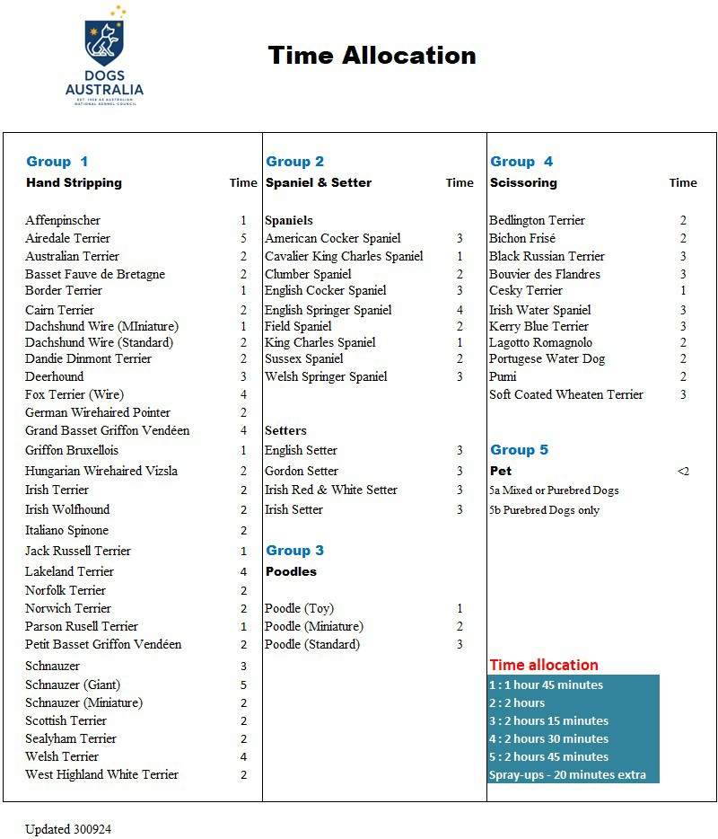

ENTERING
    - By entering DA Canine Grooming Championship show, you will also give permission to enter into The Point score Competition.

    - Please note that once an entry has been entered into the Point score Competition, it will not be removed until the full year cycle end.

    - We have 2 Point score Competitions: 1) Top Groomer of the Year 2) Rising Star of the Year

