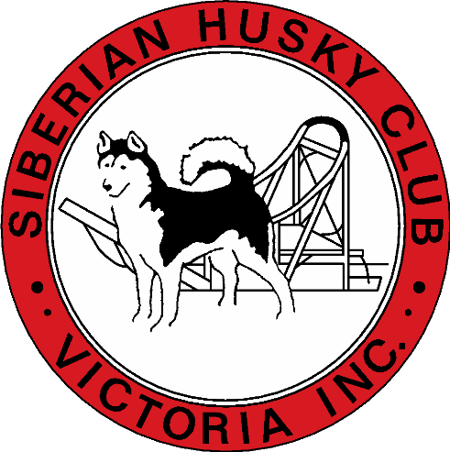
The Siberian Husky Club Of Victoria Inc
In conjunction with the Artic breed Fun match would love for you to support our club with this wonderful Raffle on Offer

1st prize
$100 Show Manager Gift Voucher
2nd prize
$50.00 Show Manager Gift Voucher
Tickets are $2 each or 3 for $5
Tickets will be sold on the day or via Show Manager Site

