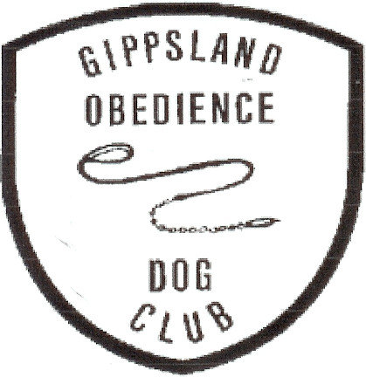
ENTRIES CLOSE SUNDAY 26TH JULY 2026 on Show Manager

GIPPSLAND OBEDIENCE DOG CLUB INC.
14TH RETRIEVING ABILITY TEST FOR GUNDOGS
NOVICE & OPEN
To be held
Gippsland Area
Location TBA

SUNDAY AUGUST 2ND 2026

JUDGE: MR DEAN FURNELL (VIC)

Check in and vetting: 8.30am - 9.00am at location
Trial Commences: 9.15am
Entry Fee: Non Members $17.00 (includes catalogue)
GODC Members $15.00 (includes catalogue)
Entries via Show Manager
Enquiries: (no calls after 9pm please) Trial Secretary 0404565255
weilanderweis1@gmail.com
Conditions of entry:
. Associate entries must have prior approval prior to entry
. Competitors may be asked to assist if required

Award and Sash for class winners Sash for 2nd and 3rd placings
Qualifying Pass Cards

Gift for highest scoring for each breed entered

Novice will be held on dummies.
Open will be held on dummies if Cold Game not available
Dummies will be provided

RATG rules are on the ANKC website http://www.ankc.org.au

Light Catering Will be Available

