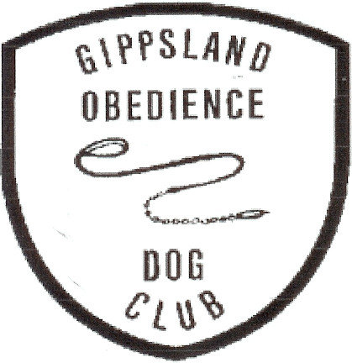
ENTRIES CLOSE 12th APRIL 2026 Show Manager

GIPPSLAND OBEDIENCE DOG CLUB INC.
13TH RETRIEVING ABILITY TEST FOR GUNDOGS
NOVICE & OPEN
To be held
Gippsland Area
Location TBA

SUNDAY APRIL 19th 2026

JUDGE: Mrs K Eltringham (Vic)

Check in and vetting: 8.30am - 9.00am at location
Trial Commences: 9.15am
Entry Fee: Non Members $17.00 (includes catalogue)
GODC Members $15.00 (includes catalogue)
Entries via Show Manager
Enquiries: (no calls after 9pm please) Trial Secretary 0404565255
weilanderweis1@gmail.com
Conditions of entry:
. Associate entries must have prior approval prior to entry
. Competitors may be asked to assist if required
Award and Sash for class winners Sash for 2nd and 3rd placings
Qualifying Pass Cards

Gift for highest scoring for each breed entered

Novice will be held on dummies.
Open will be held on dummies if Cold Game not available
Dummies will be provided.

Light Catering Will be Available

