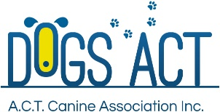

Presents A Webinar On
READING YOUR DOG’S CHANGES OF BEHAVIOUR
Presenter: ANGELA HERVEY-TENNYSON (ANKC Scent Work Judge)
Date: SUNDAY, 19 JULY 2026
Time: 7pm – 8pm via Zoom
Cost: $15 (book via Show Manager)
https://showmanager.com.au/activity/4767
Angela was employed by the government as a detector dog handler for ten years, working at airports, seaports and mail centres. While in that role, she heard about a great new dog activity in the USA - nose work. She did some research and was hooked “I love that the activity is suitable for just about all dogs, including shy and reactive ones. Dogs love to sniff, so it’s not surprising that nearly all dogs love to play the game”. She ran her first nose work course about 15 years ago at her local dog club.

In 2016, she gained her Certified Nose Work Instructor accreditation from the National Association of Canine Scent Work.

Angela runs classes whenever and wherever she can so that more people learn about the benefits of nose work for their dogs. Angela has also introduced nose work to dog breed and obedience clubs, shelters, rescues and other interested groups.

Angela is a former Australian Canine Scent Work Certifying Official and Judge.

She is a a Certified Professional Dog Trainer, with a Certificate IV in Companion Animal Services from the Delta Institute. Her education continues with attendance at various conferences/seminars/webinars/camps, etc.

Angela has been loved and owned by Soft Coated Wheaten Terriers for over 30 years, competing in conformation, obedience, herding, and most recently, scent work.
