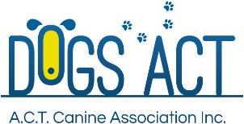

Presents A Webinar On
Problem Solving with Cues, Markers and Reward Placement
Presenter: TALIA DUELL (ANKC Scent Work Judge)
Date: 23 MARCH 2026
Time: 7pm – 8pm via Zoom
Cost: $15 (book via Show Manager)
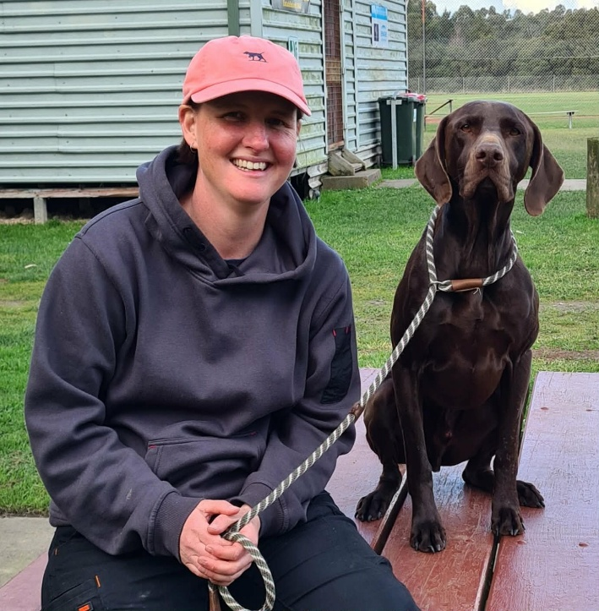
Talia’s passion for scent sports began 20 years ago when she trained her first dog for ANKC tracking. After learning about detection, she has gone on to train dogs for various roles including conservation work and truffle hunting.
Talia is one of Victoria’s foundation judges for ANKC Scent Work and has trialled two of her own dogs successfully. Her GSP, Solly gained his Masters title in 2024. She doesn't get to as many scent work trials these days as she and Solly are now a certified Search and Rescue team which takes up a lot of her time.
Talia still enjoys teaching Scent Work though and is looking forward to sharing her thoughts about markers and cues and where they fit in training for Scent Work.

