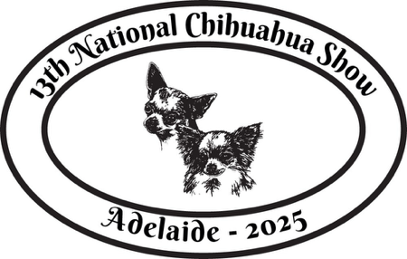

13th National Presentation Dinner

Saturday 6th September 2025 at 6:00pm David Roche Park

Contact Details

|  |  |  |  |
| --- | --- | --- | --- |
| Name |  | | |
| Postal Address |  | | |
| Suburb |  | Postcode |  |
| Phone |  | Mobile |  |
| Email |  | | |

Presentation Dinner

|  |  |  |  |
| --- | --- | --- | --- |
| Description | Qty | Price (PP) | Total |
| Presentation Dinner - Saturday 06/09/2025 |  | $50 |  |

6-8 people per table: we will try our best to seat to everyone together per returned

|  |  |
| --- | --- |
|  | Guest(s) Names and Dietary Restrictions if applicable |
| 1 |  |
| 2 |  |
| 3 |  |
| 4 |  |
| 5 |  |
| 6 |  |
| 7 |  |
| 8 |  |

Payment via Show Manager

Email completed form to bremiliegreatdanes@gmail.com

