Show Manager Raffle 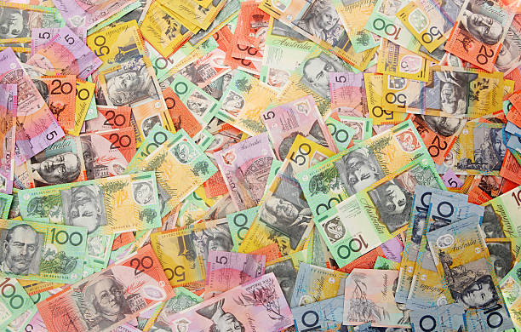 Win $500 cash

Spend it on end of financial year sales – or whatever you like and support the Oriental Breeds Society Dog Club

We appreciate your help keeping our club viable
Drawn Sunday (5th July 2026) at 12.00 noon
$10 per Ticket

