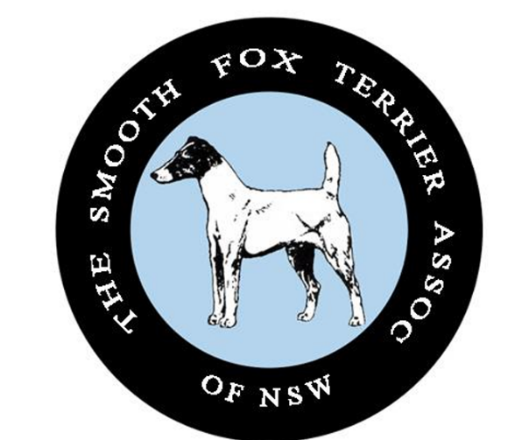
The Smooth Fox Terrier Association of NSW
Ribbon Sponsorship
2026

Prize | Cost | Sponsor
Best in Show Boxed Rosette | $60
Runner Up Best in Show Boxed Rosette | $45
Baby in Show/Opposite Baby in Show Sashes | $25
Minor in Show/Opposite Minor in Show Sashes | $25
Puppy in Show/Opposite Puppy in Show Sashes | $25
Junior in Show/Opposite Junior in Show Sashes | $25
Inter in Show/Opposite Inter in Show Sashes | $25
Aus Bred in Show/Opposite Aus Bred in Show Sashes | $25
Open In Show/Opposite Open in Show Sashes | $25
Neuter in Show Rosette | $30
Runner Up Neuter in Show Rosette | $20
Dog Challenge Rosette | $30
Reserve Dog Challenge Rosette | $20
Bitch Challenge Rosette | $30
Reserve Bitch Challenge Rosette | $20
Neuter Dog Challenge Rosette | $30
Neuter Reserve Dog Challenge Rosette | $20
Neuter Bitch Challenge Rosette | $30
Neuter Reserve Bitch Challenge Rosette | $20

