Show Manager Raffle 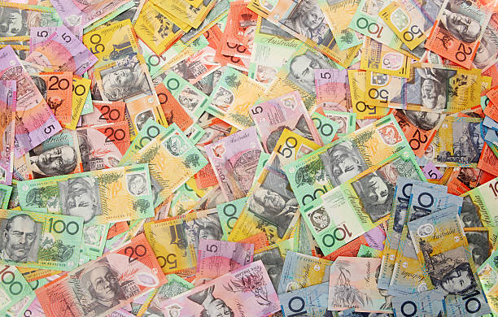 Win $500 cash

Spend it on Fuel or Easter Eggs – or whatever you like and support the Non Sporting Dog Club of WA
Drawn Easter Sunday (5th April 2026) at 7pm
$10 per Ticket

