8th Australian Weimaraner National Trophy Donations
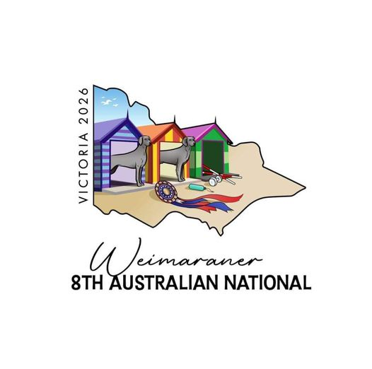

CONFORMATION TOP AWARDS
Conformation in Show | Trophy/Rosette |  | Donated by
Best in Show | Brett White Artwork | 1000
Best in Show | Boxed Rosette | 80
Runner up to Best in Show | Brett White Artwork | 700
Runner up to Best in Show | Boxed Rosette | 80
Breeder of Best in Show | Boxed Rosette | 80
Champion Puppy in Show  (Judged Baby/Minor/Puppy of breeds) | Brett White Artwork | 350
Champion Puppy in Show | Boxed Rosette | 80

CONFORMATION CLASS IN SHOW AWARDS
 | Trophy/Rosette | $ | Donated by
Best Baby Puppy in Show | Boxed Rosette/Cash | 150
Opposite Variety Baby in Show | Marellan Ribbon Rosette | 60
Best Minor Puppy in Show | Boxed Rosette & Cash | 150
Opposite Variety Minor in Show | Marellan Ribbon Rosette | 50
Best Puppy in Show | Boxed Rosette & Cash | 150
Opposite Variety Puppy in Show | Marellan Ribbon Rosette | 50
Best Junior in Show | Boxed Rosette & Cash | 150
Opposite Variety Junior in Show | Marellan Ribbon Rosette | 50
Best Intermediate in Show | Boxed Rosette & Cash | 150
Opposite Variety Intermediate in Show | Marellan Ribbon Rosette | 50
Best Aust Bred in Show | Boxed Rosette & Cash | 150
Opposite Variety Aust Bred in Show | Marellan Ribbon Rosette | 50
Best Bred By in Show | Boxed Rosette & Cash | 150
Opposite Variety Bred By in Show | Marellan Ribbon Rosette | 50
Best Open in Show | Boxed Rosette & Cash | 150
Opposite Variety Open in Show | Marellan Ribbon Rosette | 50
Best Veteran in Show | Boxed Rosette & Cash | 150
Opposite Variety Veteran in Show | Marellan Ribbon Rosette | 50
Best Neuter in Show | Boxed Rosette & Cash | 150
Runner Up Best Neuter in Show | Marellan Ribbon Rosette | 50
CONFORMATION – BREED AWARDS
Weimaraner
Best of Breed | Brett White trophy | 300
 | Marellan Ribbon Rosette | 70
Runner Up to Best of Breed | Brett White trophy | 150
 | Marellan Ribbon Rosette | 70
Challenge Dog | Glitter Bucket & Cash | 75
 | Marellan Ribbon Rosette | 45
Reserve Challenge Dog | Glitter Bucket & Cash | 75
 | Marellan Ribbon Rosette | 45
Challenge Bitch | Glitter Bucket & Cash | 75
 | Marellan Ribbon Rosette | 45
Reserve Challenge Bitch | Glitter Bucket & Cash | 75
 | Marellan Ribbon Rosette | 45
Weimaraner Longhair
Best of Breed – Longhair | Brett White trophy | 300
 | Marellan Ribbon Rosette | 70
Runner up to Best of Breed – LH | Brett White trophy | 150
 | Marellan Ribbon Rosette | 70
Challenge Dog – LH | Glitter Bucket & Cash | 75
 | Marellan Ribbon Rosette | 45
Reserve Challenge Dog – LH | Glitter Bucket & Cash | 75
 | Marellan Ribbon Rosette | 45
Challenge Bitch – LH | Glitter Bucket & Cash | 75
 | Marellan Ribbon Rosette | 45
Reserve Challenge Bitch – LH | Glitter Bucket & Cash | 75
 | Marellan Ribbon Rosette | 45

CONFORMATION - NEUTER
Weimaraner - Neuter
Best of Breed – Neuter | Boxed Rosette | 55
RU to Best of Breed – Neuter | Boxed Rosette | 55
Challenge Dog - Neuter | Marellan Tote & Cash | 45
 | Marellan Ribbon Rosette | 45
Reserve Challenge Dog – Neuter | Marellan Tote & Cash | 45
 | Marellan Ribbon Rosette | 45
Challenge Bitch – Neuter | Marellan Tote & Cash | 45
 | Marellan Ribbon Rosette | 45
Reserve Challenge Bitch – Neuter | Marellan Tote & Cash | 45
 | Marellan Ribbon Rosette | 45
Weimaraner Longhair - Neuter
Best of Breed – LH - Neuter | Boxed Rosette | 55
RU to Best of Breed – LH -Neuter | Boxed Rosette | 55
Challenge Dog – LH - Neuter | Marellan Tote & Cash | 45
 | Marellan Ribbon Rosette | 45
Reserve Challenge Dog – LH - Neuter | Marellan Tote & Cash | 45
 | Marellan Ribbon Rosette | 45
Challenge Bitch – LH -Neuter | Marellan Tote & Cash | 45
 | Marellan Ribbon Rosette | 45
Reserve Challenge Bitch – LH -Neuter | Marellan Tote & Cash | 45
 | Marellan Ribbon Rosette | 45

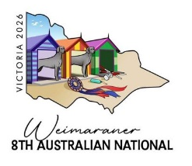

PERFORMANCE
RATG
 | Trophy/Rosette | $ | Donated by
1st Novice | Brett White Art | 100
 | Marellan Ribbon Rosette | 40
2nd Novice | Medallion & Ribbon Rosette | 35
3rd Novice | Medallion & Ribbon Rosette | 35
1st Open | Brett White Art | 100
 | Marellan Ribbon Rosette | 40
2nd Open | Medallion & Ribbon Rosette | 35
3rd Open | Medallion & Ribbon Rosette | 35
OBEDIENCE
 | Trophy/Rosette | $ |  | Donated by
HIGH IN TRIAL | Brett White Artwork | 250
1st CCD | Sports Bag & Medallion | 60
 | Marellan Ribbon Rosette | 40
2ND CCD | Medallion & Ribbon Rosette | 35
3RD CCD | Medallion & Ribbon Rosette | 35
1ST CD | Sports Bag & Medallion | 60
 | Marellan Ribbon Rosette | 40
2ND CD | Medallion & Ribbon Rosette | 35
3RD CD | Medallion & Ribbon Rosette | 35
1ST CDX | Sports Bag & Medallion | 60
 | Marellan Ribbon Rosette | 40
2ND CDX | Medallion & Ribbon Rosette | 35
3RD CDX | Medallion & Ribbon Rosette | 35
1ST UD | Sports Bag & Medallion | 60
 | Marellan Ribbon Rosette | 40
2ND UD | Medallion & Ribbon Rosette | 35
3RD UD | Medallion & Ribbon Rosette | 35
1ST UDX | Sports Bag & Medallion | 60
 | Marellan Ribbon Rosette | 40
2ND UDX | Medallion & Ribbon Rosette | 35
3RD UDX | Medallion & Ribbon Rosette | 35
RALLY
 | Trophy/Rosette | $ |  | Donated by
HIGH IN TRIAL | Brett White Artwork Valued at | 250
1ST NOVICE | Sports Bag & Medallion | 60
 | Marellan Ribbon Rosette | 40
2ND NOVICE | Medallion & Ribbon Rosette | 35
3RD NOVICE | Medallion & Ribbon Rosette | 35
1ST ADVANCED | Sports Bag & Medallion | 60
 | Marellan Ribbon Rosette | 40
2ND ADVANCED | Medallion & Ribbon Rosette | 35
3RD ADVANCED | Medallion & Ribbon Rosette | 35
1ST EXCELLENCE | Sports Bag & Medallion | 60
 | Marellan Ribbon Rosette | 40
2ND EXCELLENCE | Medallion & Ribbon Rosette | 35
3RD EXCELLENCE | Medallion & Ribbon Rosette | 35
1ST MASTERS | Sports Bag & Medallion | 60
 | Marellan Ribbon Rosette | 40
2ND MASTERS | Medallion & Ribbon Rosette | 35
3RD MASTERS | Medallion & Ribbon Rosette | 35

CONFORMATION – PROPERTY CLASSES
 |  | $ | Donated by
1st Sire and Progeny | Boxed Rosette | 60
 | Sashes for Progeny (3) | 30
2nd Sire and Progeny | Marellen Ribbon Rosette | 40
 | Sashes for Progeny (3) | 30
3rd Sire and Progeny | Marellen Ribbon Rosette | 40
 | Sashes for Progeny (3) | 30
1st Dam and Progeny | Boxed Rosette | 60
 | Sashes for Progeny (3) | 30
2nd Dam and Progeny | Marellen Ribbon Rosette | 40
 | Sashes for Progeny (3) | 30
3rd Dam and Progeny | Marellen Ribbon Rosette | 40
 | Sashes for Progeny (3) | 30
1st Breeders Team | Boxed Rosette | 60
 | Sashes for Team (4) | 40
2nd Breeders Team | Marellen Ribbon Rosette | 40
 | Sashes for Team (4) | 40
3rd Breeders Team | Marellen Ribbon Rosette | 40
 | Sashes for Team (4) | 40

