Casino & District Kennel Club Inc
MAJOR RAFFLE!!

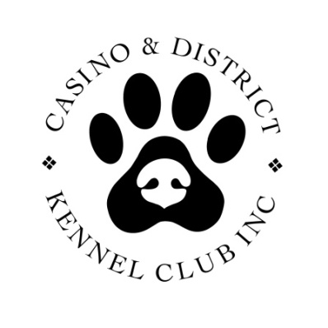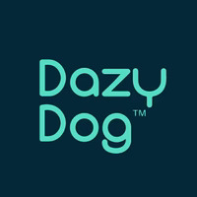

Dazy Dog bed
voucher to the value of $359

$5 per ticket, only 200 tickets
Available on Show Manager

https://www.showmanager.com.au/activity/4022

OUR ONLY FUNDRAISER FOR 2026!!!

Please support our small regional club so we can continue to put on great shows for you!

