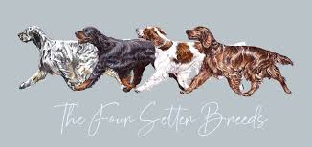

**WIN A**

**$1000**

**ST JOHN SUIT VOUCHER**

[**Best In Show - St. John Knits**](https://www.facebook.com/groups/1435154937112064/)

**TICKETS $10.00 EACH**

**ONLY 200 TICKETS AVAILABLE**

**Drawn At the completion of the sale of ALL tickets or**

**Sunday 3rd November 2024 Winner will be notified by email**

**Tickets available through SHOWMANGER – Gordon Setter Club of Victoria $1000 St john Suit Raffle**